ГУАП

КАФЕДРА 44

ОТЧЕТ   
ЗАЩИЩЕН С ОЦЕНКОЙ

ПРЕПОДАВАТЕЛЬ

|  |  |  |  |  |
| --- | --- | --- | --- | --- |
| доцент, канд. техн. наук |  |  |  | Н.Н. Решетникова |
| должность, уч. степень, звание |  | подпись, дата |  | инициалы, фамилия |

|  |
| --- |
| ОТЧЕТ О ЛАБОРАТОРНОЙ РАБОТЕ |
| СОЗДАНИЕ ДИНАМИЧЕСКИХ X3D-СЦЕН |
| по курсу: ИНТЕРАКТИВНАЯ КОМПЬЮТЕРНАЯ ГРАФИКА |
|  |
|  |

РАБОТУ ВЫПОЛНИЛ

|  |  |  |  |  |  |
| --- | --- | --- | --- | --- | --- |
| СТУДЕНТ ГР. № | 4941 |  |  |  | Н.С. Горбунов |
|  |  |  | подпись, дата |  | инициалы, фамилия |

Санкт-Петербург 2022

**Цель работы:** целью работы является приобретение навыков создания динамических X3Dсцен с использованием сенсоров и интерполяторов различных типов.

**Граф сцены:**

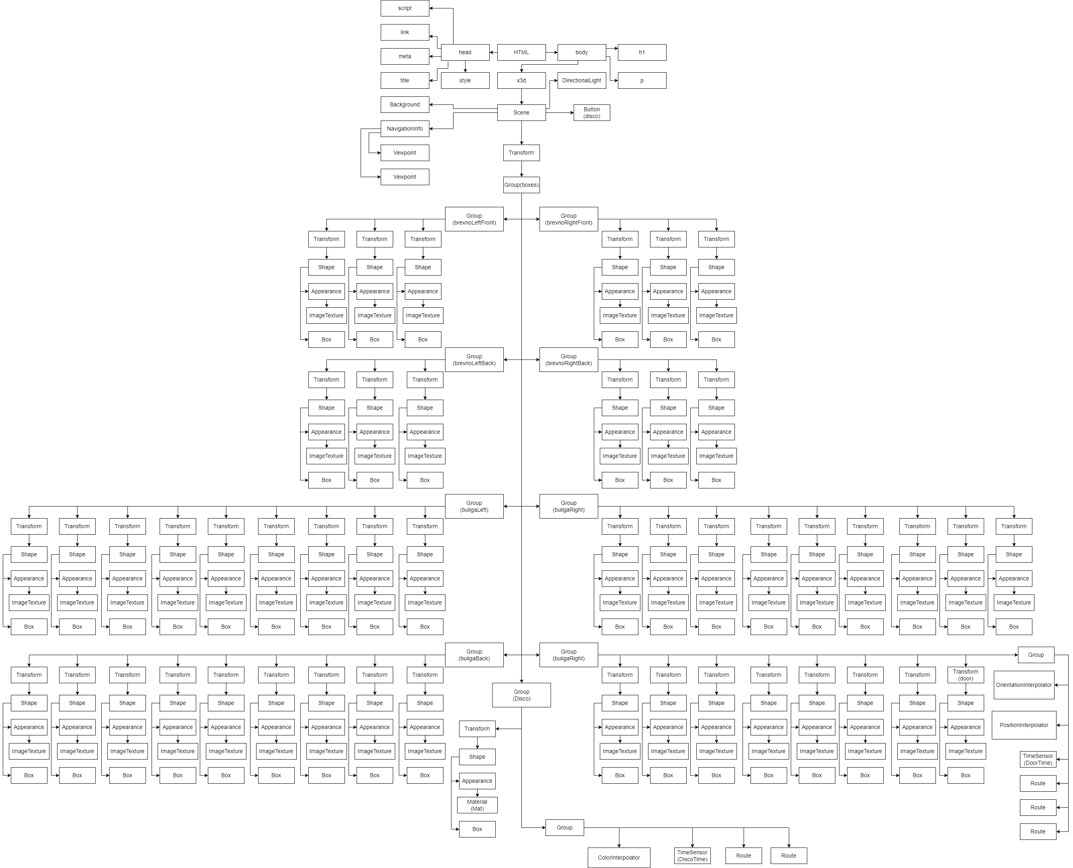





**Описание сцены:**

На сцене расположен домик в стиле майнкрафт. Если нажать на дверь, то она откроется, показывая внутренности дома. Внутри расположен объект красного цвета. По нажатию кнопки «Disco!» этот объект начнет менять цвета.

Листинг 1.

<html>

<head>

<meta charset="utf-8" />

<title> 3 Лабораторная работа </title>

<link rel="stylesheet" href="https://www.x3dom.org/download/dev/x3dom.css" />

<script src="https://www.x3dom.org/download/dev/x3dom-full.js"></script>

<style>

x3d {

border: 4px solid darkblue;

}

</style>

<script type="text/javascript">

document.onload = function() {

var seconds = new Date().getTime() / 1000;

document.getElementById("DoorTime").setAttribute("pauseTime", seconds);

document.getElementById("DoorTime").setAttribute("isPaused", "true");

document.getElementById("DiscoTime").setAttribute("pauseTime", seconds);

document.getElementById("DiscoTime").setAttribute("isPaused", "true");

var button1 = document.createElement("button");

button1.id = "disco";

button1.innerHTML = "Disco!";

document.getElementById("x3d").appendChild(button1);

document.getElementById("disco").onclick = function()

{

var seconds = new Date().getTime() / 1000;

document.getElementById("DiscoTime").setAttribute("isPaused", "false");

document.getElementById("DiscoTime").setAttribute("resumeTime", seconds);

document.getElementById("DiscoTime").setAttribute("pauseTime", seconds+1000);

}

}

function openDoor()

{

var seconds = new Date().getTime() / 1000;

document.getElementById("DoorTime").setAttribute("isPaused", "false");

document.getElementById("DoorTime").setAttribute("resumeTime", seconds);

document.getElementById("DoorTime").setAttribute("pauseTime", seconds+1);

}

</script>

</head>

<body style='overflow-y:hidden;'>

<h1>Горбунов Никита Сергеевич<h1>

<p>

Лабораторная работа 3

</p>

<x3d width='1000px' height='600px' id = "x3d">

<Scene>

<Background skyColor='0.1 0.45 1'> </Background>

<NavigationInfo>

<Viewpoint id="front" position="0 0 25" orientation="0 0 1 0" description="camera"></Viewpoint>

<Viewpoint id="front2" position="-15 2 0" orientation="0 1.4 0.03 4.5" description="camera"></Viewpoint>

<Viewpoint id="front3" position="15 2 0" orientation="0 -1.4 0.03 4.5" description="camera"></Viewpoint>

</NavigationInfo>

<DirectionalLight direction='-1 -2 -2' color='red' intensity='1'></DirectionalLight>

<transform translation='0 0 0'>

<Group DEF="boxes">

<Group DEF="brevnoLeftFront">

<transform translation='-6 0 0' DEF="block-600">

<shape render="true" visible="true" bboxcenter="0,0,0" bboxsize="-1,-1,-1" ispickable="true">

<appearance sorttype="auto" alphaclipthreshold="0.1">

<ImageTexture url = "brevno.jpg"> </ImageTexture>

</appearance>

<box solid="true" ccw="true" usegeocache="true" lit="true" size="3,3,3"></box>

</shape>

</transform>

<transform translation='-6 3 0' DEF="block-630">

<shape render="true" visible="true" bboxcenter="0,0,0" bboxsize="-1,-1,-1" ispickable="true">

<appearance sorttype="auto" alphaclipthreshold="0.1">

<ImageTexture url = "brevno.jpg"> </ImageTexture>

</appearance>

<box solid="true" ccw="true" usegeocache="true" lit="true" size="3,3,3"></box>

</shape>

</transform>

<transform translation='-6 6 0' DEF="block-660">

<shape render="true" visible="true" bboxcenter="0,0,0" bboxsize="-1,-1,-1" ispickable="true">

<appearance sorttype="auto" alphaclipthreshold="0.1">

<ImageTexture url = "brevno.jpg"> </ImageTexture>

</appearance>

<box solid="true" ccw="true" usegeocache="true" lit="true" size="3,3,3"></box>

</shape>

</transform>

</Group>

<Group DEF="brevnoRightFront">

<transform translation='6 0 0' DEF="block600">

<shape render="true" visible="true" bboxcenter="0,0,0" bboxsize="-1,-1,-1" ispickable="true">

<appearance sorttype="auto" alphaclipthreshold="0.1">

<ImageTexture url = "brevno.jpg"> </ImageTexture>

</appearance>

<box solid="true" ccw="true" usegeocache="true" lit="true" size="3,3,3"></box>

</shape>

</transform>

<transform translation='6 3 0' DEF="block630">

<shape render="true" visible="true" bboxcenter="0,0,0" bboxsize="-1,-1,-1" ispickable="true">

<appearance sorttype="auto" alphaclipthreshold="0.1">

<ImageTexture url = "brevno.jpg"> </ImageTexture>

</appearance>

<box solid="true" ccw="true" usegeocache="true" lit="true" size="3,3,3"></box>

</shape>

</transform>

<transform translation='6 6 0' DEF="block660">

<shape render="true" visible="true" bboxcenter="0,0,0" bboxsize="-1,-1,-1" ispickable="true">

<appearance sorttype="auto" alphaclipthreshold="0.1">

<ImageTexture url = "brevno.jpg"> </ImageTexture>

</appearance>

<box solid="true" ccw="true" usegeocache="true" lit="true" size="3,3,3"></box>

</shape>

</transform>

</Group>

<Group DEF="brevnoLeftBack">

<transform translation='-6 0 -12' DEF="block-60-12">

<shape render="true" visible="true" bboxcenter="0,0,0" bboxsize="-1,-1,-1" ispickable="true">

<appearance sorttype="auto" alphaclipthreshold="0.1">

<ImageTexture url = "brevno.jpg"> </ImageTexture>

</appearance>

<box solid="true" ccw="true" usegeocache="true" lit="true" size="3,3,3"></box>

</shape>

</transform>

<transform translation='-6 3 -12' DEF="block-63-12">

<shape render="true" visible="true" bboxcenter="0,0,0" bboxsize="-1,-1,-1" ispickable="true">

<appearance sorttype="auto" alphaclipthreshold="0.1">

<ImageTexture url = "brevno.jpg"> </ImageTexture>

</appearance>

<box solid="true" ccw="true" usegeocache="true" lit="true" size="3,3,3"></box>

</shape>

</transform>

<transform translation='-6 6 -12' DEF="block-66-12">

<shape render="true" visible="true" bboxcenter="0,0,0" bboxsize="-1,-1,-1" ispickable="true">

<appearance sorttype="auto" alphaclipthreshold="0.1">

<ImageTexture url = "brevno.jpg"> </ImageTexture>

</appearance>

<box solid="true" ccw="true" usegeocache="true" lit="true" size="3,3,3"></box>

</shape>

</transform>

</Group>

<Group DEF="brevnoRightBack">

<transform translation='6 0 -12' DEF="block60-12">

<shape render="true" visible="true" bboxcenter="0,0,0" bboxsize="-1,-1,-1" ispickable="true">

<appearance sorttype="auto" alphaclipthreshold="0.1">

<ImageTexture url = "brevno.jpg"> </ImageTexture>

</appearance>

<box solid="true" ccw="true" usegeocache="true" lit="true" size="3,3,3"></box>

</shape>

</transform>

<transform translation='6 3 -12' DEF="block63-12">

<shape render="true" visible="true" bboxcenter="0,0,0" bboxsize="-1,-1,-1" ispickable="true">

<appearance sorttype="auto" alphaclipthreshold="0.1">

<ImageTexture url = "brevno.jpg"> </ImageTexture>

</appearance>

<box solid="true" ccw="true" usegeocache="true" lit="true" size="3,3,3"></box>

</shape>

</transform>

<transform translation='6 6 -12' DEF="block66-12">

<shape render="true" visible="true" bboxcenter="0,0,0" bboxsize="-1,-1,-1" ispickable="true">

<appearance sorttype="auto" alphaclipthreshold="0.1">

<ImageTexture url = "brevno.jpg"> </ImageTexture>

</appearance>

<box solid="true" ccw="true" usegeocache="true" lit="true" size="3,3,3"></box>

</shape>

</transform>

</Group>

<Group DEF="buligaLeft">

<transform translation='-6 0 -3'>

<shape render="true" visible="true" bboxcenter="0,0,0" bboxsize="-1,-1,-1" ispickable="true">

<appearance>

<ImageTexture url = "buliga.jpg"> </ImageTexture>

</appearance>

<box solid="true" ccw="true" usegeocache="true" lit="true" size="3,3,3"></box>

</shape>

</transform>

<transform translation='-6 0 -6'>

<shape render="true" visible="true" bboxcenter="0,0,0" bboxsize="-1,-1,-1" ispickable="true">

<appearance>

<ImageTexture url = "buliga.jpg"> </ImageTexture>

</appearance>

<box solid="true" ccw="true" usegeocache="true" lit="true" size="3,3,3"></box>

</shape>

</transform>

<transform translation='-6 0 -9'>

<shape render="true" visible="true" bboxcenter="0,0,0" bboxsize="-1,-1,-1" ispickable="true">

<appearance>

<ImageTexture url = "buliga.jpg"> </ImageTexture>

</appearance>

<box solid="true" ccw="true" usegeocache="true" lit="true" size="3,3,3"></box>

</shape>

</transform>

<transform translation='-6 3 -3'>

<shape render="true" visible="true" bboxcenter="0,0,0" bboxsize="-1,-1,-1" ispickable="true">

<appearance>

<ImageTexture url = "buliga.jpg"> </ImageTexture>

</appearance>

<box solid="true" ccw="true" usegeocache="true" lit="true" size="3,3,3"></box>

</shape>

</transform>

<transform translation='-6 3 -6'>

<shape render="true" visible="true" bboxcenter="0,0,0" bboxsize="-1,-1,-1" ispickable="true">

<appearance>

<ImageTexture url = "buliga.jpg"> </ImageTexture>

</appearance>

<box solid="true" ccw="true" usegeocache="true" lit="true" size="3,3,3"></box>

</shape>

</transform>

<transform translation='-6 3 -9'>

<shape render="true" visible="true" bboxcenter="0,0,0" bboxsize="-1,-1,-1" ispickable="true">

<appearance>

<ImageTexture url = "buliga.jpg"> </ImageTexture>

</appearance>

<box solid="true" ccw="true" usegeocache="true" lit="true" size="3,3,3"></box>

</shape>

</transform>

<transform translation='-6 6 -3'>

<shape render="true" visible="true" bboxcenter="0,0,0" bboxsize="-1,-1,-1" ispickable="true">

<appearance>

<ImageTexture url = "buliga.jpg"> </ImageTexture>

</appearance>

<box solid="true" ccw="true" usegeocache="true" lit="true" size="3,3,3"></box>

</shape>

</transform>

<transform translation='-6 6 -6'>

<shape render="true" visible="true" bboxcenter="0,0,0" bboxsize="-1,-1,-1" ispickable="true">

<appearance>

<ImageTexture url = "buliga.jpg"> </ImageTexture>

</appearance>

<box solid="true" ccw="true" usegeocache="true" lit="true" size="3,3,3"></box>

</shape>

</transform>

<transform translation='-6 6 -9'>

<shape render="true" visible="true" bboxcenter="0,0,0" bboxsize="-1,-1,-1" ispickable="true">

<appearance>

<ImageTexture url = "buliga.jpg"> </ImageTexture>

</appearance>

<box solid="true" ccw="true" usegeocache="true" lit="true" size="3,3,3"></box>

</shape>

</transform>

</Group>

<Group DEF="buligaRight">

<transform translation='6 0 -3'>

<shape render="true" visible="true" bboxcenter="0,0,0" bboxsize="-1,-1,-1" ispickable="true">

<appearance>

<ImageTexture url = "buliga.jpg"> </ImageTexture>

</appearance>

<box solid="true" ccw="true" usegeocache="true" lit="true" size="3,3,3"></box>

</shape>

</transform>

<transform translation='6 0 -6'>

<shape render="true" visible="true" bboxcenter="0,0,0" bboxsize="-1,-1,-1" ispickable="true">

<appearance>

<ImageTexture url = "buliga.jpg"> </ImageTexture>

</appearance>

<box solid="true" ccw="true" usegeocache="true" lit="true" size="3,3,3"></box>

</shape>

</transform>

<transform translation='6 0 -9'>

<shape render="true" visible="true" bboxcenter="0,0,0" bboxsize="-1,-1,-1" ispickable="true">

<appearance>

<ImageTexture url = "buliga.jpg"> </ImageTexture>

</appearance>

<box solid="true" ccw="true" usegeocache="true" lit="true" size="3,3,3"></box>

</shape>

</transform>

<transform translation='6 3 -3'>

<shape render="true" visible="true" bboxcenter="0,0,0" bboxsize="-1,-1,-1" ispickable="true">

<appearance>

<ImageTexture url = "buliga.jpg"> </ImageTexture>

</appearance>

<box solid="true" ccw="true" usegeocache="true" lit="true" size="3,3,3"></box>

</shape>

</transform>

<transform translation='6 3 -6'>

<shape render="true" visible="true" bboxcenter="0,0,0" bboxsize="-1,-1,-1" ispickable="true">

<appearance>

<ImageTexture url = "buliga.jpg"> </ImageTexture>

</appearance>

<box solid="true" ccw="true" usegeocache="true" lit="true" size="3,3,3"></box>

</shape>

</transform>

<transform translation='6 3 -9'>

<shape render="true" visible="true" bboxcenter="0,0,0" bboxsize="-1,-1,-1" ispickable="true">

<appearance>

<ImageTexture url = "buliga.jpg"> </ImageTexture>

</appearance>

<box solid="true" ccw="true" usegeocache="true" lit="true" size="3,3,3"></box>

</shape>

</transform>

<transform translation='6 6 -3'>

<shape render="true" visible="true" bboxcenter="0,0,0" bboxsize="-1,-1,-1" ispickable="true">

<appearance>

<ImageTexture url = "buliga.jpg"> </ImageTexture>

</appearance>

<box solid="true" ccw="true" usegeocache="true" lit="true" size="3,3,3"></box>

</shape>

</transform>

<transform translation='6 6 -6'>

<shape render="true" visible="true" bboxcenter="0,0,0" bboxsize="-1,-1,-1" ispickable="true">

<appearance>

<ImageTexture url = "buliga.jpg"> </ImageTexture>

</appearance>

<box solid="true" ccw="true" usegeocache="true" lit="true" size="3,3,3"></box>

</shape>

</transform>

<transform translation='6 6 -9'>

<shape render="true" visible="true" bboxcenter="0,0,0" bboxsize="-1,-1,-1" ispickable="true">

<appearance>

<ImageTexture url = "buliga.jpg"> </ImageTexture>

</appearance>

<box solid="true" ccw="true" usegeocache="true" lit="true" size="3,3,3"></box>

</shape>

</transform>

</Group>

<Group DEF="buligaBack">

<transform translation='-3 0 -12'>

<shape render="true" visible="true" bboxcenter="0,0,0" bboxsize="-1,-1,-1" ispickable="true">

<appearance>

<ImageTexture url = "buliga.jpg"> </ImageTexture>

</appearance>

<box solid="true" ccw="true" usegeocache="true" lit="true" size="3,3,3"></box>

</shape>

</transform>

<transform translation='0 0 -12'>

<shape render="true" visible="true" bboxcenter="0,0,0" bboxsize="-1,-1,-1" ispickable="true">

<appearance>

<ImageTexture url = "buliga.jpg"> </ImageTexture>

</appearance>

<box solid="true" ccw="true" usegeocache="true" lit="true" size="3,3,3"></box>

</shape>

</transform>

<transform translation='3 0 -12'>

<shape render="true" visible="true" bboxcenter="0,0,0" bboxsize="-1,-1,-1" ispickable="true">

<appearance>

<ImageTexture url = "buliga.jpg"> </ImageTexture>

</appearance>

<box solid="true" ccw="true" usegeocache="true" lit="true" size="3,3,3"></box>

</shape>

</transform>

<transform translation='-3 3 -12'>

<shape render="true" visible="true" bboxcenter="0,0,0" bboxsize="-1,-1,-1" ispickable="true">

<appearance>

<ImageTexture url = "buliga.jpg"> </ImageTexture>

</appearance>

<box solid="true" ccw="true" usegeocache="true" lit="true" size="3,3,3"></box>

</shape>

</transform>

<transform translation='0 3 -12'>

<shape render="true" visible="true" bboxcenter="0,0,0" bboxsize="-1,-1,-1" ispickable="true">

<appearance>

<ImageTexture url = "buliga.jpg"> </ImageTexture>

</appearance>

<box solid="true" ccw="true" usegeocache="true" lit="true" size="3,3,3"></box>

</shape>

</transform>

<transform translation='3 3 -12'>

<shape render="true" visible="true" bboxcenter="0,0,0" bboxsize="-1,-1,-1" ispickable="true">

<appearance>

<ImageTexture url = "buliga.jpg"> </ImageTexture>

</appearance>

<box solid="true" ccw="true" usegeocache="true" lit="true" size="3,3,3"></box>

</shape>

</transform>

<transform translation='-3 6 -12'>

<shape render="true" visible="true" bboxcenter="0,0,0" bboxsize="-1,-1,-1" ispickable="true">

<appearance>

<ImageTexture url = "buliga.jpg"> </ImageTexture>

</appearance>

<box solid="true" ccw="true" usegeocache="true" lit="true" size="3,3,3"></box>

</shape>

</transform>

<transform translation='0 6 -12'>

<shape render="true" visible="true" bboxcenter="0,0,0" bboxsize="-1,-1,-1" ispickable="true">

<appearance>

<ImageTexture url = "buliga.jpg"> </ImageTexture>

</appearance>

<box solid="true" ccw="true" usegeocache="true" lit="true" size="3,3,3"></box>

</shape>

</transform>

<transform translation='3 6 -12'>

<shape render="true" visible="true" bboxcenter="0,0,0" bboxsize="-1,-1,-1" ispickable="true">

<appearance>

<ImageTexture url = "buliga.jpg"> </ImageTexture>

</appearance>

<box solid="true" ccw="true" usegeocache="true" lit="true" size="3,3,3"></box>

</shape>

</transform>

</Group>

<Group DEF="buligaFront">

<transform translation='-3 0 0'>

<shape render="true" visible="true" bboxcenter="0,0,0" bboxsize="-1,-1,-1" ispickable="true">

<appearance>

<ImageTexture url = "buliga.jpg"> </ImageTexture>

</appearance>

<box solid="true" ccw="true" usegeocache="true" lit="true" size="3,3,3"></box>

</shape>

</transform>

<transform translation='3 0 0'>

<shape render="true" visible="true" bboxcenter="0,0,0" bboxsize="-1,-1,-1" ispickable="true">

<appearance>

<ImageTexture url = "buliga.jpg"> </ImageTexture>

</appearance>

<box solid="true" ccw="true" usegeocache="true" lit="true" size="3,3,3"></box>

</shape>

</transform>

<transform translation='-3 3 0'>

<shape render="true" visible="true" bboxcenter="0,0,0" bboxsize="-1,-1,-1" ispickable="true">

<appearance>

<ImageTexture url = "buliga.jpg"> </ImageTexture>

</appearance>

<box solid="true" ccw="true" usegeocache="true" lit="true" size="3,3,3"></box>

</shape>

</transform>

<transform translation='3 3 0'>

<shape render="true" visible="true" bboxcenter="0,0,0" bboxsize="-1,-1,-1" ispickable="true">

<appearance>

<ImageTexture url = "buliga.jpg"> </ImageTexture>

</appearance>

<box solid="true" ccw="true" usegeocache="true" lit="true" size="3,3,3"></box>

</shape>

</transform>

<transform translation='-3 6 0'>

<shape render="true" visible="true" bboxcenter="0,0,0" bboxsize="-1,-1,-1" ispickable="true">

<appearance>

<ImageTexture url = "buliga.jpg"> </ImageTexture>

</appearance>

<box solid="true" ccw="true" usegeocache="true" lit="true" size="3,3,3"></box>

</shape>

</transform>

<transform translation='0 6 0'>

<shape render="true" visible="true" bboxcenter="0,0,0" bboxsize="-1,-1,-1" ispickable="true">

<appearance>

<ImageTexture url = "buliga.jpg"> </ImageTexture>

</appearance>

<box solid="true" ccw="true" usegeocache="true" lit="true" size="3,3,3"></box>

</shape>

</transform>

<transform translation='3 6 0'>

<shape render="true" visible="true" bboxcenter="0,0,0" bboxsize="-1,-1,-1" ispickable="true">

<appearance>

<ImageTexture url = "buliga.jpg"> </ImageTexture>

</appearance>

<box solid="true" ccw="true" usegeocache="true" lit="true" size="3,3,3"></box>

</shape>

</transform>

<transform DEF="Door" translation='0 1.5 1.1' rotation='0 0 0 0'>

<shape onclick="openDoor();" render="true" visible="true" bboxcenter="0,0,0" bboxsize="-1,-1,-1" ispickable="true">

<appearance>

<ImageTexture url = "door.png"> </ImageTexture>

</appearance>

<box solid="true" ccw="true" usegeocache="true" lit="true" size="3,6,0.5"></box>

</shape>

</transform>

<Group>

<orientationinterpolator DEF="DoorOpenRotation" key="0 0.5 1" keyvalue="0 0 0 0, 0 1 0 -1.57, 0 0 0 0">

</orientationinterpolator>

<positioninterpolator DEF="DoorOpenPosition" key="0 0.5 1" keyvalue="0 1.5 1.1, 1.2 1.5 0, 0 1.5 1.1"></positioninterpolator>

<timesensor id="DoorTime" def="DoorTime" cycleinterval="2" loop="true" enabled="true" first="false" isPaused = "false"></timesensor>

<route fromnode="DoorTime" fromfield="fraction_changed" tonode="DoorOpenRotation" tofield="set_fraction">

</route>

<route fromnode="DoorTime" fromfield="fraction_changed" tonode="DoorOpenPosition" tofield="set_fraction">

</route>

<route fromnode="DoorOpenRotation" fromfield="value_changed" tonode="Door" tofield="set_rotation">

</route>

<route fromnode="DoorOpenPosition" fromfield="value_changed" tonode="Door" tofield="set_translation">

</route>

</Group>

</Group>

<Group DEF="dicso">

<transform translation = '0 3 -6'>

<shape render="true" visible="true" bboxcenter="0,0,0" bboxsize="-1,-1,-1" ispickable="true">

<appearance>

<material def="Mat" ambientintensity="0.2" diffusecolor="0.8,0.8,0.8" emissivecolor="0,0,0" shininess="0.2" specularcolor="0,0,0"></material>

</appearance>

<box solid="true" ccw="true" usegeocache="true" lit="true" size="9,9,9"></box>

</shape>

</transform>

<Group>

<colorinterpolator def="ColInt" key="0 0.33 0.66 1" keyvalue="1 0 0, 0 1 0, 0 0 1, 1 0 0"></colorinterpolator>

<timesensor id="DiscoTime" def="DiscoTime" cycleinterval="5" loop="true" enabled="true" first="false"></timesensor>

<route fromnode="DiscoTime" fromfield="fraction_changed" tonode="ColInt" tofield="set_fraction">

</route>

<route fromnode="ColInt" fromfield="value_changed" tonode="Mat" tofield="set_diffuseColor">

</route>

</Group>

</Group>

</Group>

</transform>

</Scene>

</x3d>

</body>

</html>

**Скриншоты сцены:**

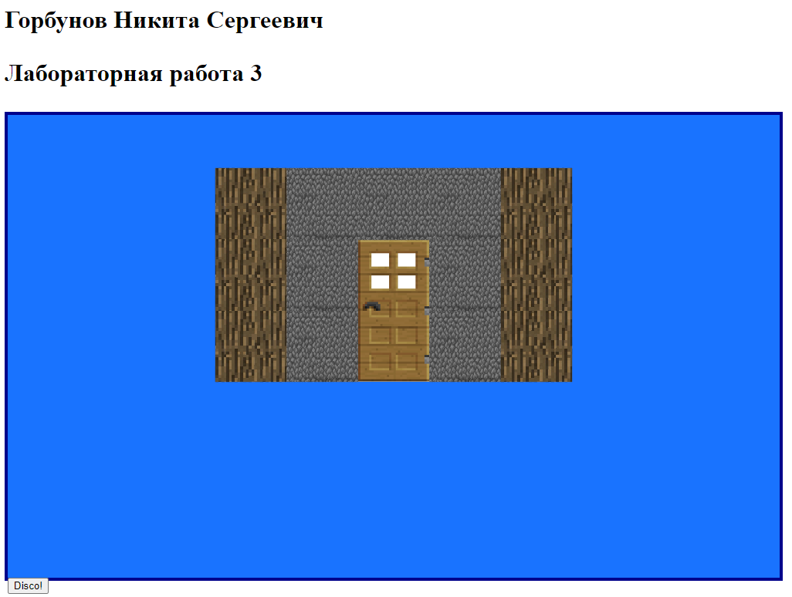

Рисунок 1. Начальный вид

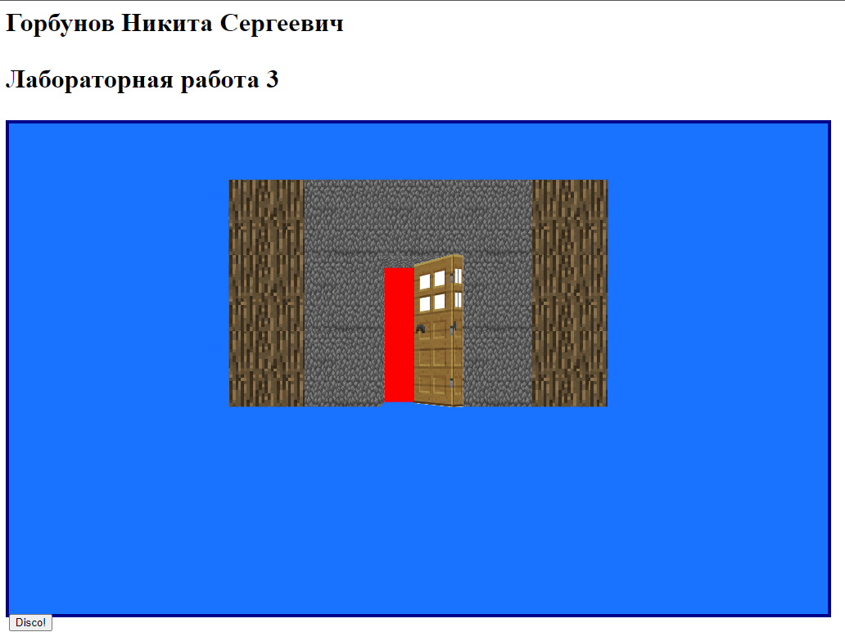

Рисунок 2. Дверь открывается

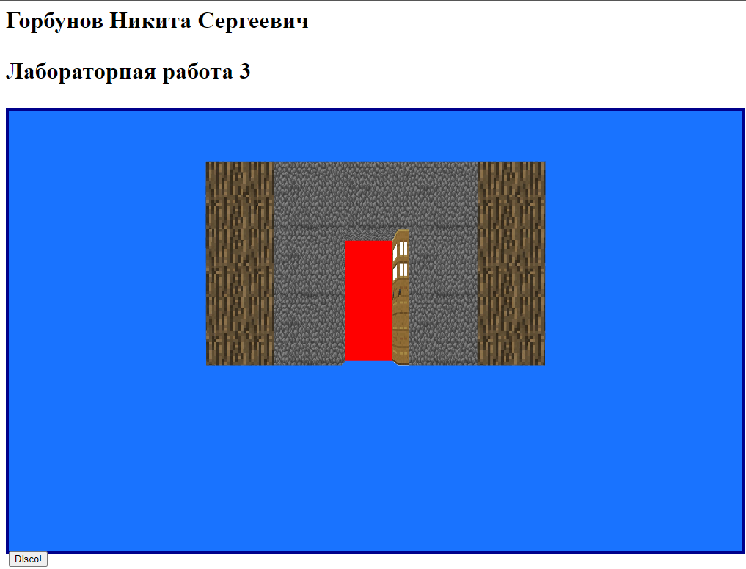

Рисунок 3. Дверь открыта

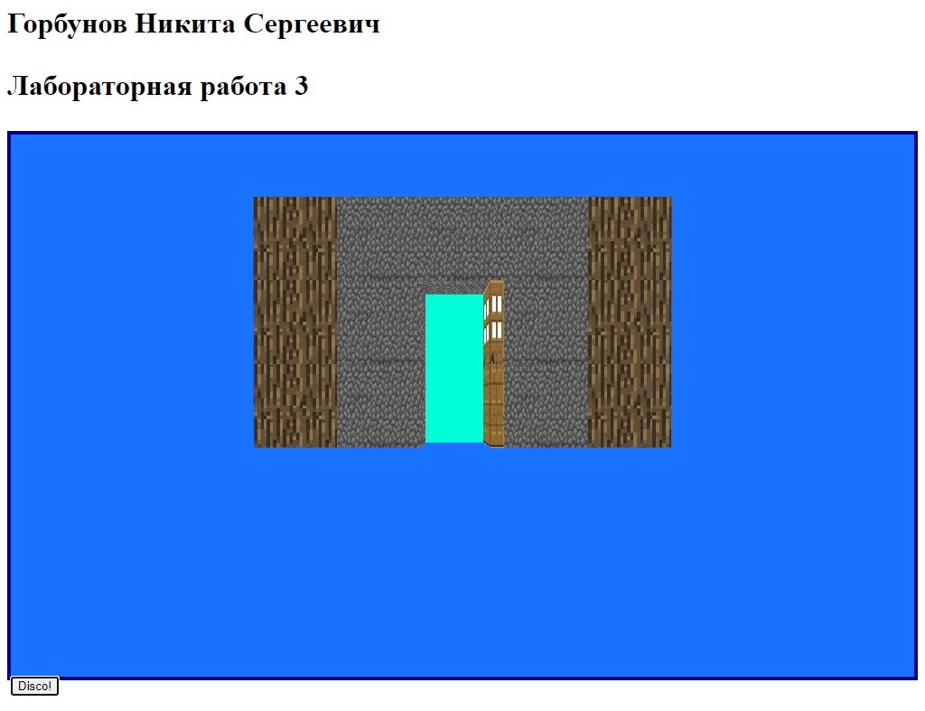

Рисунок 4. Диско!

**Вывод:** приобрел навыки создания динамических X3Dсцен с использованием сенсоров и интерполяторов различных типов. Создал анимацию открытия\закрытия двери и изменение цвета по нажатию на кнопку.